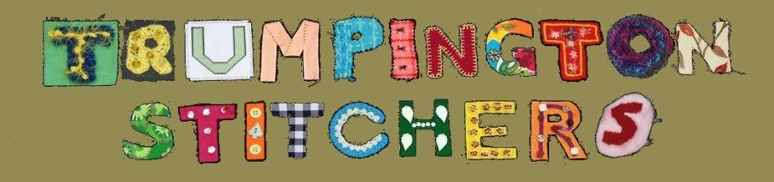

Welcome to our Monday meeting
This information sheet tells you what you need to know about how we tend to do things, so that you feel at home as quickly as possible.
We are very pleased to see you and hope you enjoy meeting everyone. We usually have between 8 and 12 people each week but our membership is about 20, with several others who drop by when they can, so you may meet different people each week.
You are welcome to drop in occasionally or come regularly. Drop in sessions cost £3. If you plan to come at least 10 times in the year, it works out best to become a Member for £10 (payable 6 monthly at £5) and then the weekly charge is £2. We will ask you to fill out a form with your contact details so that we have you on our database for newsletters and information about events and workshops.
We have a Steering Group that meets quarterly and five of those people take turns to “host” each week. Their job is to open up, set up the hall, welcome new people and make sure they have whatever help they need with their stitching, collect the weekly subs, and make sure we all get offered a hot drink at some point. Anyone can help make drinks and wash up, don’t be shy!
Most people bring some stitching that they are working on at home but some people come to us wanting to learn a new skill. We don’t formally teach but between us we know how to do most kinds of stitching so we can help you get started. We have some “Starter Packs” for beginners in knitting, crochet, hand embroidery, patchwork and machine stitching. You are welcome to take one of these at no cost (although small donations always welcome).
We have basic equipment and sewing machines in the cupboards and in our stores outside we have boxes of fabric, mostly small amounts so for any proper dressmaking you will probably need to buy something yourself. But you are very welcome to browse and use what we have for smaller projects.
We leave by 9, so we start to pack up at 8.45. Everyone who is able to helps with putting chairs, tables and equipment away.
Please do just mingle and chat, get to know us and ask any questions you have.
The hosts names are:
- Carol Holloway
- Dilly Bradford
- Jackie Covill
- Philippa Slatter

