KNITTED TEDDY FAMILIES

This teddy is knitted in one piece, all in garter stitch and is a great way to use up your oddments of wool. The basic pattern is simple, and can be used with different thicknesses of wool and needles to produce different sizes of teddy for a family.
Just make sure you knit firmly with a small enough needle size to make sure the stuffing cannot come out. You can use two strands of yarn at once for a very firm result.
When you have made one, you will have ideas of how to add your own touches! You might like longer legs or a shaped neck. Just make sure the front matches the back, that’s all!

Cast on 8 sts.
Knit 20 rows. Leave stitches on the needle.
Cast on 8 sts. Knit 20 rows. This makes the legs.
Knit across 16 sts. Knit 14 rows.
Cast on 10 sts. at the beginning of the next two rows (36 sts.)
Knit 10 rows (this makes the arms)
Cast off 10 sts at beginning of next 2 rows (16 sts)
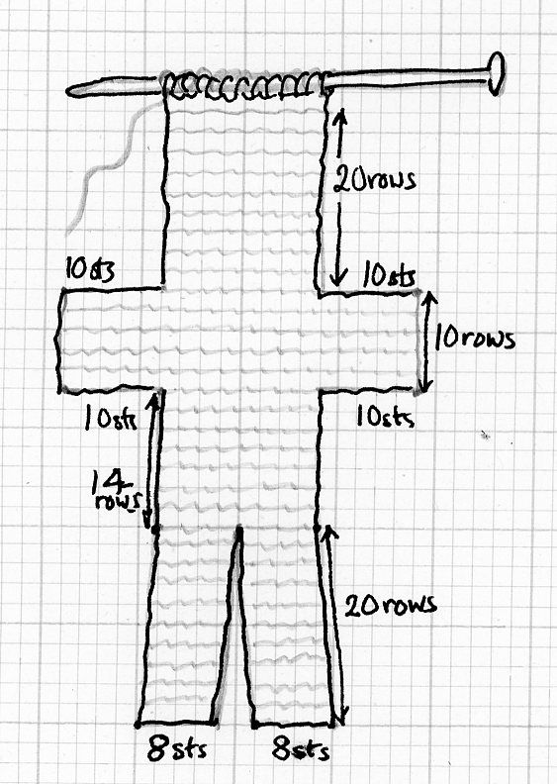
Knit 20 rows for the head.
This completes one side of the teddy.

Continue down the back as follows:
Knit 20 rows (head)
Cast on 10 sts at the beginning of the next 2 rows (36 stitches)
Knit 10 rows (arms)
Cast off 10 sts. at the beginning of the next 2 rows (16 sts)
Knit 14 rows.
Knit 8 sts. Turn and knit 20 rows. Cast off.
Join yarn to remaining 8sts. Knit 20 rows. Cast off.

Fold in half and sew up around edge, leaving a gap at the crotch. Form the ears by stitching across the corners of the head.
Insert stuffing and finish sewing up. Crochet a scarf or tie a ribbon round the neck
Embroider a simple face of eyes, nose and mouth.

You can use a different colour for the head, paws and feet, and to make your Ted trousers and a top.

